**Telephone Payment Billing System Activity Diagram**

This is the Activity UML diagram of Telephone Billing Payment System which shows the flows between the activity of Bill, Connection Types, Connections , Customers. The main activity involved in this UML Activity Diagram of Telephone Billing Payment System are as follows.

* Bill Activity
* Connection Types Activity
* Connections Activity
* Activity

## Features Of The Activity UML Diagram Of Telephone Billing Payment System

* Admin User can search Bill, view description of a selected Bill, add Bill, update Bill, and delete Bill.
* It shows the activity flow of editing, adding and updating of Connection Types
* User will be able to search and generate report of Connections, Customers.
* All objects such as(Bill, Connection Types)are interlinked
* It shows the full description and flow of Bill, Customers, Connections, Connection Types

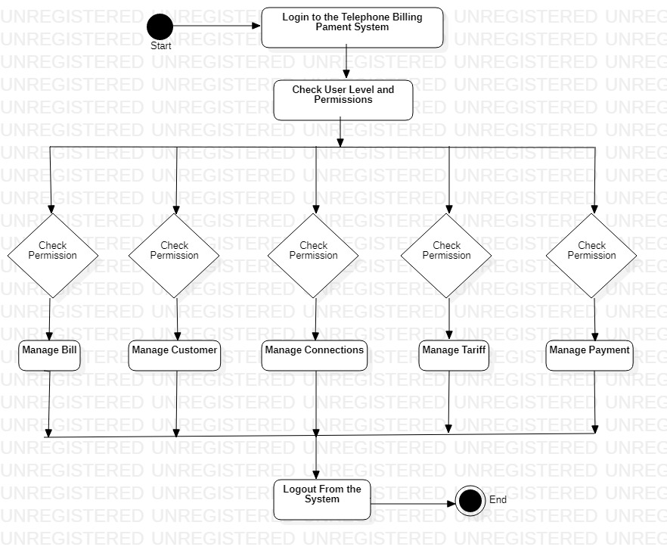

## Login Activity Diagram Of Telephone Billing Payment System:

This is the Login Activity Diagram of Telephone Billing Payment System. Which shows the flow of Login Activity, where admin will be able to login using their username and password. After login user can manage all the operations on Connections, Bill, Connection Types. Customers are secure and user can access these page after login. The diagram below helps demonstrate how the login page works in a Telephone Billing Payment System. The various objects in the Connections, Bill, Connection Types, and Customer page-interact over the course of the Activity, and user will not be able to access this page without verifying their identity.

